Chapter 10, Problem 34.

Use mesh analysis to find I_{o} in Fig. 10.28 (for Example 10.10).

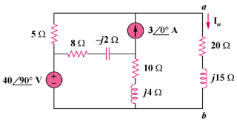

Figure 10.28
For Prob. 10.34.

